1. **Introduction**

Key business goals for the system are to create:

* A system/infrastructure that enables users to reserve parking spaces using a laptop or phone.
* Enables a parking attendant to monitor the parking facility
* A system that can be reused and scaled for another parking facility (garage or lot)
* Provide owner with facility usage data to initially include average usage, peak usage hours, revenue and must be extensible for adding more analysis algorithms

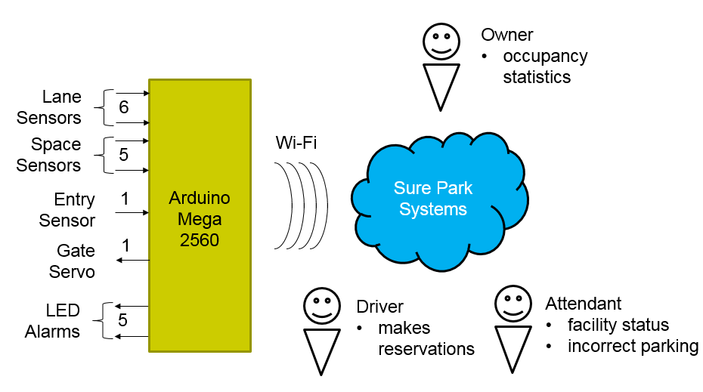

1. **Project Context**

**2.1) Market Context**

|  |  |
| --- | --- |
| **Stakeholders** | Garage owner, GTPS, Attendant, drivers, team members, team mentor, Smart phone company, App market, Credit card company, System installer, Project Manager |
| **Quality** | Reduce driver frustration, more efficiently utilize the space, reducing liabilities, reducing operating costs for owner |
| **Functional expectations** | H/W control and reservation parking space, monitoring and managing parking facility |
| **Product packaging** | H/W devices, Server, Network device, DB, user manual and S/W. |

**2.2) Organizational Context**

|  |  |
| --- | --- |
| **Structure** | The development team has 5 members. |
| **Culture** | Customer oriented. |

**2.3) Business Context**

|  |  |
| --- | --- |
| **Strategies** | We will focus on the successful deployment of the initial system. And then we will extend markets into global. |
| **Internal and external providers** | H/W parts company, Server provider |
| **Cost obligations and assets** | PC, Server, Development expense |
| **Profit model** | Maintenance fee/every month, Installation fee. |
| **Competition** | Other development team. |
| **Future direction** | GTPS would like to scale the system to include larger parking lots and garages and, if the solution is successful for them, market the system to other garage owners around the world. |

**2.4) Technical Context**

|  |  |
| --- | --- |
| **Languages** | JAVA, C, C++ |
| **tools** | Eclipse, Arduino IDE, JDK |
| **Operating system and hardware platform** | Arduino, Windows, Mac OSX |
| **Implementation frameworks** | Arduino |

1. **High Level Functional Requirement**

|  |  |  |
| --- | --- | --- |
| **ID** | **Functional Requirement** | **Description** |
| FR-01 | The system shall detect cars in parking space. | Arduino H/W control |
| FR-02 | The system shall detect when cars are parked incorrectly (straddling parking slot lanes). If a car straddle parking slot lanes, the system shall blink LED. And the system shall inform it to attendant in 2 minutes. |
| FR-03 | The system shall open and close an entry gate. |
| FR-04 | The system shall detect when cars arrive at the gate. |
| FR-05 | The system shall allow drivers to reserve parking spaces.  Reservations will be made via mobile app, laptop, or desktop app for drivers. | Reservation system for drivers |
| FR-06 | For reservation, drivers must sign up the system. The system will prevent unauthorized users. |
| FR-07 | The system shall provide available parking slot information to drivers. |
| FR-08 | Drivers shall provide a license plate (identifying information), the day and time they would like to park, and credit card information (payment information). |
| FR-09 | The system shall return confirmation information to driver if reservation is success. |
| FR-10 | The system shall check confirmation information and verify the deriver's information and reservation. | When drivers come up an entry gate. Checking system. |
| FR-11 | The system shall configure "grace period". | Operating a "grace period" |
| FR-12 | If a customer does not show up at the start of their reservation time, the system will be held for a "grace period". |
| FR-13 | If the customer doesn't show up with in grace period, the system will expire that reservation. So that customers lose their reservation. | No-show process |
| FR-14 | The system shall calculate the hour for parking and it will charge on their credit card. | Charge system |
| FR-15 | The system will show which parking spots are open or not. | Monitoring system for attendant |
| FR-16 | The system will show how long a car has occupied a particular parking spot. |  |
| FR-17 | The system will notify the attendant if a driver parks other spot, and it will reallocate the parking spaces. |  |
| FR-18 | The system will notify the attendant after 2 minutes if a car crosses the lanes and LED is blinking. |  |
| FR-19 | The system will show facility usage and revenue.  The facility usage include average occupancy, peak usage hours, parking slot statistics. | Management system for owner |
| FR-20 | The system shall extend analysis algorithms or applications without disrupting operations. | Management system for owner  Extend system |
| FR-21 | The system shall provide login system for preventing unauthorized users. | System security |
| FR-22 | The system should not allow anyone to view facility data (reservations, credit cards, etc.) without owner. |  |
|  |  |  |
|  |  |  |
|  |  |  |
|  |  |  |
|  |  |  |
|  |  |  |
|  |  |  |

1. **Use Case Scenario**

**4.1) UC-01** Reserve parking spaces

|  |  |
| --- | --- |
| **ID: UC-01** | **Description** |
| **Title** | (FR-05 ~ FR-09) Reserve parking spaces |
| **Stakeholders** | Derivers who want to reserve parking spaces. |
| **Description** | 1. The Sure-Park system allows authorized drivers to reserve parking system. 2. The system shows available parking space to drivers. 3. If there are parking spaces available, drivers must input a license plate, the day and time they would like to park and credit card information. 4. If all required items are ok, the system will return confirmation information to drivers. |

**4.2) UC-02** Show up and parking scenario

|  |  |
| --- | --- |
| **ID: UC-02** | **Description** |
| **Title** | (FR-04, FR-10) Show up and parking scenario |
| **Stakeholders** | Drivers who reserve parking space. Attendants who check reservation. |
| **Description** | 1. The system detects presence of a car at the gate. 2. A driver provide confirmation information to system. 3. The system verify driver’s information and confirm the reservation. 4. The system give a driver a unique alpha-numeric identifier.   (A unique alpha-numeric identifier can be a parking spot like ‘A’ to ‘E’?)   1. The system lift the entry gate and allow the deriver to enter the facility. 2. A driver park a car. |

**4.3) UC-03 ‘**No show scenario’

|  |  |
| --- | --- |
| **ID: UC-03** | **Description** |
| **Title** | No show scenario & grace period 이남진 |
| **Stakeholders** |  |
| **Description** |  |

**4.3) UC-04 ‘**Get out the garage & charge scenario’

|  |  |
| --- | --- |
| **ID: UC-04** | **Description** |
| **Title** | Get out the garage & charge scenario 오정균 |
| **Stakeholders** |  |
| **Description** |  |

**4.3) UC-05 ‘**Wrong parking scenario’

|  |  |
| --- | --- |
| **ID: UC-05** | **Description** |
| **Title** | Wrong parking scenario 김재헌 |
| **Stakeholders** |  |
| **Description** |  |

**4.3) UC-06 ‘**Monitoring scenario’

|  |  |
| --- | --- |
| **ID: UC-06** | **Description** |
| **Title** | Monitoring scenario for attendant and owner 박천수 |
| **Stakeholders** |  |
| **Description** |  |

**4.3) UC-07 ‘**Management scenario’

|  |  |
| --- | --- |
| **ID: UC-07** | **Description** |
| **Title** | Management scenario for owner 박천수 |
| **Stakeholders** |  |
| **Description** |  |

1. **Quality Attribute**

|  |  |  |  |  |
| --- | --- | --- | --- | --- |
| **ID** | **Quality Attribute** | **Priority** | **Description** | **Stakeholder(s)** |
| QA-01 | Modifiability  (김지향) |  | The system is able to scale out to other parking facilities including large and small parking lots and garages. The size of parking facilities will vary from parking lots with 5 parking places, to multilevel parking garages with 500 or more parking spaces. | Owner, developer |
| QA-02 | Availability  이남진 |  | Each H/W parts and system work correctly. For example, if LED doesn't blink when a car parked incorrectly, it can cause increasing operating cost. | Owner, Attendant, developer |
| QA-03 | Security  오정균 |  | The system should prevent unauthorized users from accessing information such as reservation, credit card, and so forth. | All stakeholders |
| QA-04 | Extensibility  (김지향) |  | The system should be extensible to enable developers to add more analysis algorithms or analysis applications without disrupting operation to add the new features. | Owner, Developer |
| QA-05 | Performance  김재헌 |  | Drivers will be able to determine if there are parking spaces available in a garage and reserve a spot. | Owner, attendant, developer |
| QA-06 | Performance  김재헌 |  | The owner would like to have basic statistics on facility usage to include average occupancy, peak usage hours, parking slot statistics and revenue. |  |
| QA-07 | Interoperability  박천수 |  | Arduino and system communicate well. |  |

1. **Quality Attribute Scenario**

**6.1) QA-01**

|  |  |
| --- | --- |
| **Title** | Scale out to other parking facilities |
| **ID** | QA-01 |
| **Quality Attribute** | Modifiability |
| **Scenario** |  |
| **Source of stimulus** |  |
| **Stimulus** |  |
| **Artifact** |  |
| **Environment** |  |
| **Response** |  |
| **Response measure** |  |

**6.4) QA-04**

|  |  |
| --- | --- |
| **Title** | Add more analysis algorithms or analysis applications |
| **ID** | QA-04 |
| **Quality Attribute** | Extensibility |
| **Scenario** | Developers make a new algorithm and test it without disrupting operations. |
| **Source of stimulus** | A new algorithm or application |
| **Stimulus** | Add the system |
| **Artifact** | the system |
| **Environment** | Normal operation (run time) |
| **Response** | No disrupting operations. |
| **Response measure** | No downtown |

1. **Quality Attribute Utility**

|  |  |  |  |  |
| --- | --- | --- | --- | --- |
| **ID** | **Quality Attribute** | **Description** | **Difficulty** | **Priority** |
|  |  |  | Difficult | High |
|  |  |  | Challenging | Medium |
|  |  |  | Easy | Low |
|  |  |  |  |  |
|  |  |  |  |  |

1. **Business Constraint**

|  |  |  |
| --- | --- | --- |
| **ID** | **Business Constraint** | **Description** |
| BC-01 | Reducing complain | GTPS wants to reduce driver frustration when customers find an available parking slots and reserve them. |
| BC-02 | Increasing profits | More efficiently utilize the space in the parking facilities. |
| BC-03 | Reducing liabilities | Reduce traffic congestion and the chance for accidents inside the parking facilities. |
| BC-04 | Reducing operating costs | More efficiently utilize personnel and reduce the number of employee. |
| BC-05 | Applying other garage | GTPS would like to market the system to other garage owners around the world. |
| BC-06 | Delivery | The system should be delivered in 5 weeks. |
| BC-07 | Availability of workforce | The team is consist of 5 members. Java expert is only 1 person. |

1. **Technical Constraint**

|  |  |  |
| --- | --- | --- |
| **ID** | **Technical Constraint** | **Description** |
| TC-01 | H/W System | Wi-Fi enabled Arduino(mega 2560)  - Flash Memory: 256KB of which 8KB used by bootloader  - SRAM: 8KB  - EEPROM: 4KB  - Clock Speed: 16MHz |
| TC-02 | Programming language | For development Arduino: C/C++  For server and application: Java |
| TC-03 | Network | Wi-Fi  Wi-Fi configuration |
|  |  |  |
|  |  |  |

**Q&A**

1. The document says, the system will return confirmation information when a driver reserve parking space. And system also give a driver "parking space identifier" when a driver show up an entry gate after reservation. "**confirmation information**" and "**parking space information**" can be same? Or it's just our decision?
2. Can a driver select a special parking spot? For example, parking spots are available with A,B and E. At this time, can a driver choice “A” parking spot?
3. How can we catch up when driver go out of garage? Attendant or IR Detector sensor?
4. Could you tell me “reallocation” scenario in detail?